## Reports/ Rx Reports/ Missing Erxs Report

Request:

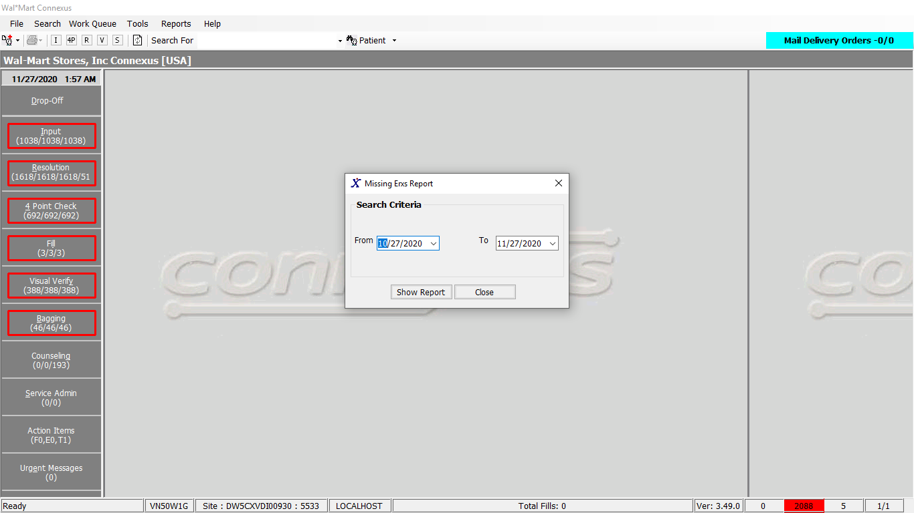

Response:

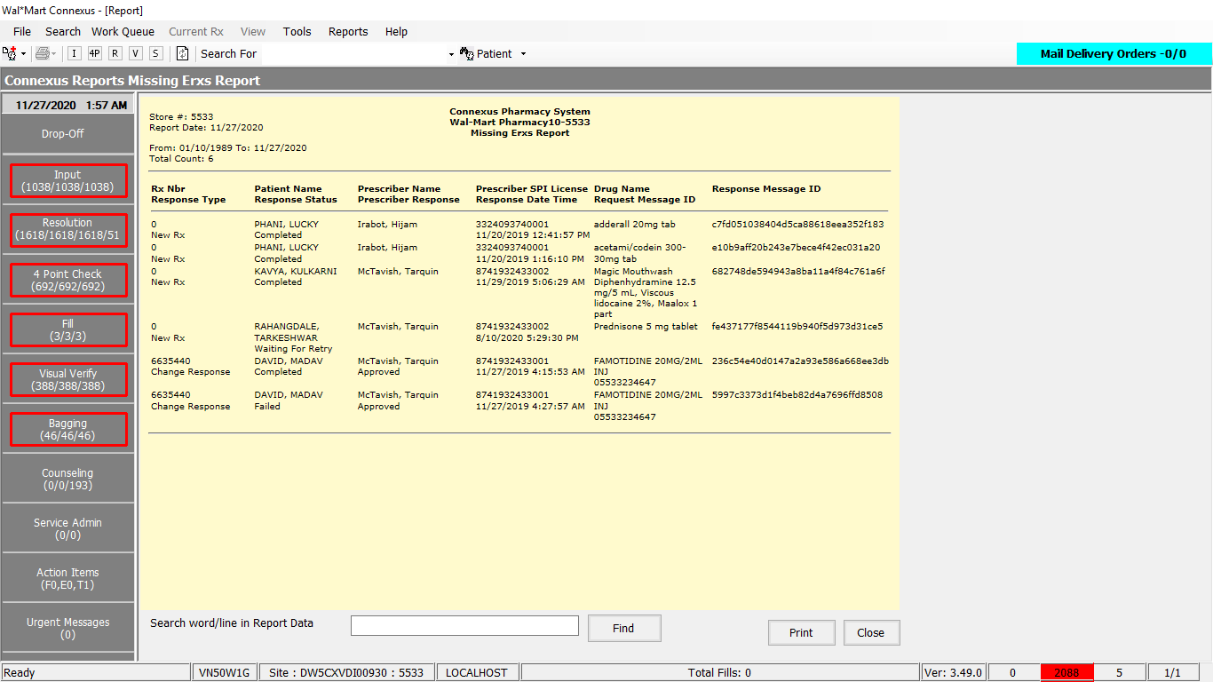

Queries:

Friend Const GetMissingErxsReportData As String = "SELECT rerr.rx_response_id,

rerr.rx_resp_type_code,

rerr.transmit_ts,

rerr.response_stat_code

FROM raw_eltnc_rx_resp rerr

LEFT JOIN rx_order_detail rod

ON rerr.rx_response_id = rod.rx_response_id

WHERE rod.rx_response_id IS NULL

AND rerr.rx_resp_type_code IN (?,?,?)

AND rerr.response_stat_code IN (?,?,?)

AND rerr.create_ts::DATETIME YEAR TO DAY BETWEEN ? AND ?"

DAL:

Public Function GetMissingErxsReportData(ByVal siteId As Integer, ByVal fromDate As DateTime, ByVal ToDate As DateTime) As List(Of GetMissingErxsReportDataBE) Implements IReportDAL.GetMissingErxsReportData

Using (New Tracer(ConnexusCommonConstants.ConnexusTracer))

Dim missingErxsReportDataList As New List(Of GetMissingErxsReportDataBE)

Dim missingErxsReportData As New GetMissingErxsReportDataBE

Dim paramList As New List(Of DbParameter)

paramList.Add(ParameterHelper.BuildParameter("NewRx", DbType.Int16, ERXDotResponseTypeCodes.RESNEWRX))

paramList.Add(ParameterHelper.BuildParameter("RenewalResponse", DbType.Int16, ERXDotResponseTypeCodes.RESREFRX))

paramList.Add(ParameterHelper.BuildParameter("ChangeResponse", DbType.Int16, ERXDotResponseTypeCodes.RESCHGRX))

paramList.Add(ParameterHelper.BuildParameter("Completed", DbType.Int16, ERXDotRequestStatusCodes.REQCOMPLETE))

paramList.Add(ParameterHelper.BuildParameter("WaitingForRetry", DbType.Int16, ERXDotRequestStatusCodes.REQWAITINGFORRETRY))

paramList.Add(ParameterHelper.BuildParameter("Failed", DbType.Int16, ERXDotRequestStatusCodes.REQFAILED))

paramList.Add(ParameterHelper.BuildParameter("FromDate", DbType.Date, fromDate))

paramList.Add(ParameterHelper.BuildParameter("ToDate", DbType.Date, ToDate))

Dim dataReader As IDataReader = ExecuteReader(DatabaseEnum.rx21c, siteId, ReportQueries.GetMissingErxsReportData, paramList)

While dataReader.Read()

missingErxsReportData = New GetMissingErxsReportDataBE

If Not dataReader.IsDBNull(dataReader.GetOrdinal("rx_response_id")) Then

missingErxsReportData.RxResponseID = CInt(dataReader("rx_response_id"))

End If

If Not dataReader.IsDBNull(dataReader.GetOrdinal("rx_resp_type_code")) Then

missingErxsReportData.RxResponseTypeCode = CInt(dataReader("rx_resp_type_code"))

End If

If Not dataReader.IsDBNull(dataReader.GetOrdinal("transmit_ts")) Then

missingErxsReportData.MissedErxDate = Convert.ToDateTime(dataReader("transmit_ts"))

End If

If Not dataReader.IsDBNull(dataReader.GetOrdinal("response_stat_code")) Then

missingErxsReportData.ResponseStatusCode = CInt(dataReader("response_stat_code"))

End If

missingErxsReportData.ResponseBlob = GetResponseXmlBlob(siteId, missingErxsReportData.RxResponseID)

missingErxsReportDataList.Add(missingErxsReportData)

End While

If missingErxsReportDataList.HasRecords Then

Return missingErxsReportDataList

Else

Return Nothing

End If

End Using

End Function